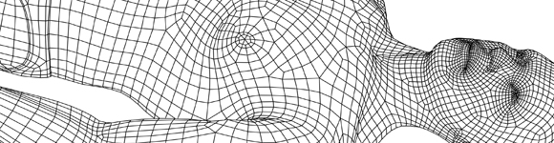
TEACH_{SimFaculty}

Training in Educational Approaches Course for Healthcare Simulation Faculty

2019-2020 Course Contacts

RSCH Contact

Mrs Holly Davies
Simulation Coordinator
Education Centre
Royal Surrey County Hospital
Egerton Road
Guildford
Surrey
GU2 7XX
Tel: 01483 571122 ext 4388
rschteachsimfaculty@gmail.com

Tunbridge Wells Contact

Miss Nicola Matthews
Education and Training Centre,
Level -2,
Tunbridge Wells Hospital at Pembury,
Tunbridge Road,
Pembury
TN2 4QJ

Tel: 01892 635667
twteachsimfaculty@gmail.com

William Harvey Hospital Contact

Miss Jess Blake
Simulation Administrator
Medical Education Centre
William Harvey Hospital
Kennington Road
Willesborough
Ashford
Kent
TN24 0LZ

Tel: 01233 616185 Ext:723 6185
ashfordteachsimfaculty@gmail.com

Worthing Hospital Contact

Malika Frayard-Smith
Worthing Health Education Centre
Worthing Hospital
Lyndhurst Road
BN11 2DH
Tel 01903 205111ext 84223

worthingteachsimfaculty@gmail.com

